CHAPTER 10
Biotechnology and Its Applications
• Biotechnology and Its Applications

10 | WHAT THIS CHAPTER IS ABOUT

• Biotechnology, as learnt in the previous chapter, essentially deals with the industrial-scale production of biopharmaceuticals and biologicals using genetically modified microbes, fungi, plants and animals.
The applications of biotechnology include therapeutics, diagnostics, genetically modified crops for agriculture, processed food, bioremediation, waste treatment, and energy production.
There are three critical research areas of biotechnology:
1 | Providing the best catalyst in the form of an improved organism, usually a microbe or a pure enzyme.
2 | Creating optimal conditions through engineering for a catalyst to act.
3 | Downstream processing technologies to purify the protein / organic compound.

This chapter looks at how human beings have used biotechnology to improve the quality of human life, especially in the fields of food production and health.
10.1 | BIOTECHNOLOGICAL APPLICATIONS IN AGRICULTURE

There are three options that can be thought of for increasing food production:
1 | Agro-chemical based agriculture.
2 | Organic agriculture.
3 | Genetically engineered crop-based agriculture.

10.1 | Why conventional methods were not enough

The Green Revolution succeeded in tripling the food supply, but yet it was not enough to feed the growing human population. Increased yields have partly been due to the use of improved crop varieties, but mainly due to better management practices and the use of agrochemicals (fertilisers and pesticides). However, for farmers in the developing world, agrochemicals are often too expensive, and further increases in yield with existing varieties are not possible using conventional breeding.
10.1 | Tissue culture, totipotency and micro-propagation

As traditional breeding techniques failed to keep pace with demand and to provide sufficiently fast and efficient systems for crop improvement, another technology called tissue culture got developed. Scientists learnt, during the 1950s, that whole plants could be regenerated from explants.
• An explant is any part of a plant taken out and grown in a test tube, under sterile conditions in special nutrient media. The capacity to generate a whole plant from any cell / explant is called totipotency.
• The nutrient medium must provide a carbon source such as sucrose and also inorganic salts, vitamins, amino acids and growth regulators like auxins, cytokinins, etc.
By applying these methods it is possible to achieve propagation of a large number of plants in very short durations.
• This method of producing thousands of plants through tissue culture is called micro-propagation. Each of these plants is genetically identical to the original plant from which it was grown, i.e., they are somaclones. Many important food plants like tomato, banana, apple, etc., have been produced on a commercial scale using this method.
Another important application of the method is the recovery of healthy plants from diseased plants. Even if a plant is infected with a virus, the meristem (apical and axillary) is free of virus. Hence, one can remove the meristem and grow it in vitro to obtain virus-free plants. Scientists have succeeded in culturing meristems of banana, sugarcane, potato, etc.
10.1 | Somatic hybridisation: the pomato

Scientists have even isolated single cells from plants and, after digesting their cell walls, have isolated naked protoplasts (surrounded by plasma membranes). Isolated protoplasts from two different varieties of plants -- each having a desirable character -- can be fused to get hybrid protoplasts, which can be further grown to form a new plant.
• These hybrids are called somatic hybrids, while the process is called somatic hybridisation.
For example, a protoplast of tomato fused with that of potato, and then grown, forms new hybrid plants combining tomato and potato characteristics. This has been achieved -- resulting in the formation of pomato. Unfortunately, this plant did not have all the desired combination of characteristics for its commercial utilisation.
10.1 | Genetically Modified Organisms (GMO)

• Plants, bacteria, fungi and animals whose genes have been altered by manipulation are called Genetically Modified Organisms (GMO). GMOs are created by using methods other than natural methods to transfer one or more genes from one organism to another, generally using recombinant DNA technology.
GM plants have been useful in increasing crop yields. More specifically, genetic modification has:
Benefit of genetic modification | What it achieves
(i) Tolerance to abiotic stresses | Made crops more tolerant to cold, drought, salt and heat.
(ii) Less chemical pesticide | Reduced reliance on chemical pesticides (pest-resistant crops).
(iii) Less post-harvest loss | Helped to reduce post-harvest losses.
(iv) Efficient mineral use | Increased efficiency of mineral usage by plants (this prevents early exhaustion of soil fertility).
(v) Better nutrition | Enhanced nutritional value of food, e.g., golden rice, i.e., Vitamin 'A' enriched rice.

In addition, GM has been used to create tailor-made plants to supply alternative resources to industries, in the form of starches, fuels and pharmaceuticals.
10.1 | Pest-resistant plants (1): Bt cotton

One application of biotechnology in agriculture is the production of pest-resistant plants, which could decrease the amount of pesticide used. Bt toxin is produced by a bacterium called Bacillus thuringiensis (Bt for short). The Bt toxin gene has been cloned from the bacteria and expressed in plants to provide resistance to insects without the need for insecticides -- in effect creating a bio-pesticide. Examples are Bt cotton, Bt corn, rice, tomato, potato and soyabean, etc.
Some strains of Bacillus thuringiensis produce proteins that kill certain insects such as lepidopterans (tobacco budworm, armyworm), coleopterans (beetles) and dipterans (flies, mosquitoes). B. thuringiensis forms protein crystals during a particular phase of its growth, and these crystals contain a toxic insecticidal protein.
[NOTE] Why does the Bt toxin not kill the Bacillus itself? Because the Bt toxin protein exists as inactive protoxins. It becomes toxic only after an insect ingests it, so the crystal is harmless while stored inside the bacterium. (This is the answer to Exercise 4: the crystals do not kill the bacteria because the toxin is inactive.)

The mechanism of insect killing runs as follows:
1 | An insect ingests the inactive protoxin.
2 | The alkaline pH of the gut solubilises the crystals, converting the protoxin into the active form of the toxin.
3 | The activated toxin binds to the surface of midgut epithelial cells and creates pores.
4 | The pores cause cell swelling and lysis, and eventually the death of the insect.

Specific Bt toxin genes were isolated from Bacillus thuringiensis and incorporated into several crop plants such as cotton (Figure 10.1). The choice of genes depends upon the crop and the targeted pest, as most Bt toxins are insect-group specific.
cry gene | Pest it controls
cryIAc and cryIIAb | Control the cotton bollworms.
cryIAb | Controls the corn borer.

[NOTE] The toxins are coded by a gene family called cry; there are a number of them, and cryIAc is one member. (The NCERT line 'the toxin is coded by a gene cryIAc named cry' compresses this family / member relationship.)

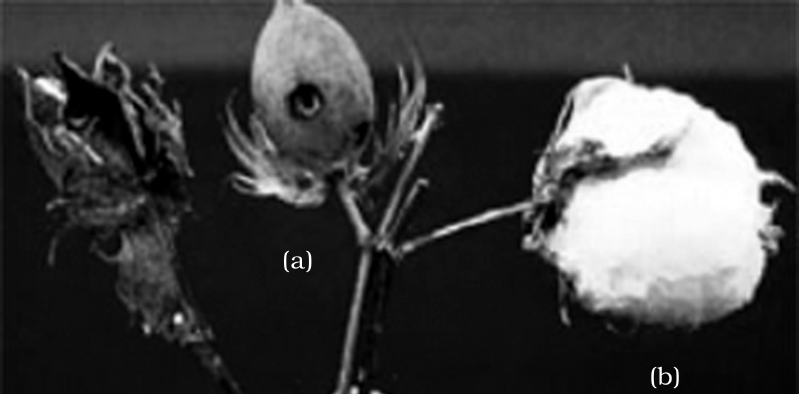
Fig. 10.1 -- Cotton boll: (a) a cotton boll destroyed by bollworms (dark, dried and shrivelled on the left); (b) a fully mature cotton boll (the open white boll on the right). The (a) / (b) contrast is one of tone, not colour -- dark versus white -- so it survives this monochrome reproduction exactly as printed. The centre boll, green and still closed in the source photograph and mid-grey here, is an unopened boll that NCERT does not label.
10.1 | Pest-resistant plants (2): RNA interference (RNAi)

Several nematodes parasitise a wide variety of plants and animals, including human beings. A nematode Meloidegyne incognitia infects the roots of tobacco plants and causes a great reduction in yield. A novel strategy to prevent this infestation was based on the process of RNA interference (RNAi).
• RNAi takes place in all eukaryotic organisms as a method of cellular defence. It involves silencing of a specific mRNA due to a complementary dsRNA molecule that binds to and prevents translation of the mRNA (silencing). The source of this complementary RNA could be an infection by viruses having RNA genomes, or mobile genetic elements (transposons) that replicate via an RNA intermediate.
The nematode was defeated by turning RNAi against it:
1 | Using Agrobacterium vectors, nematode-specific genes were introduced into the host plant (Figure 10.2).
2 | The DNA was introduced such that it produced both sense and anti-sense RNA in the host cells.
3 | Being complementary to each other, these two RNAs formed a double-stranded RNA (dsRNA) that initiated RNAi and thus silenced the specific mRNA of the nematode.
4 | The parasite could not survive in a transgenic host expressing specific interfering RNA, so the transgenic plant protected itself from the parasite.

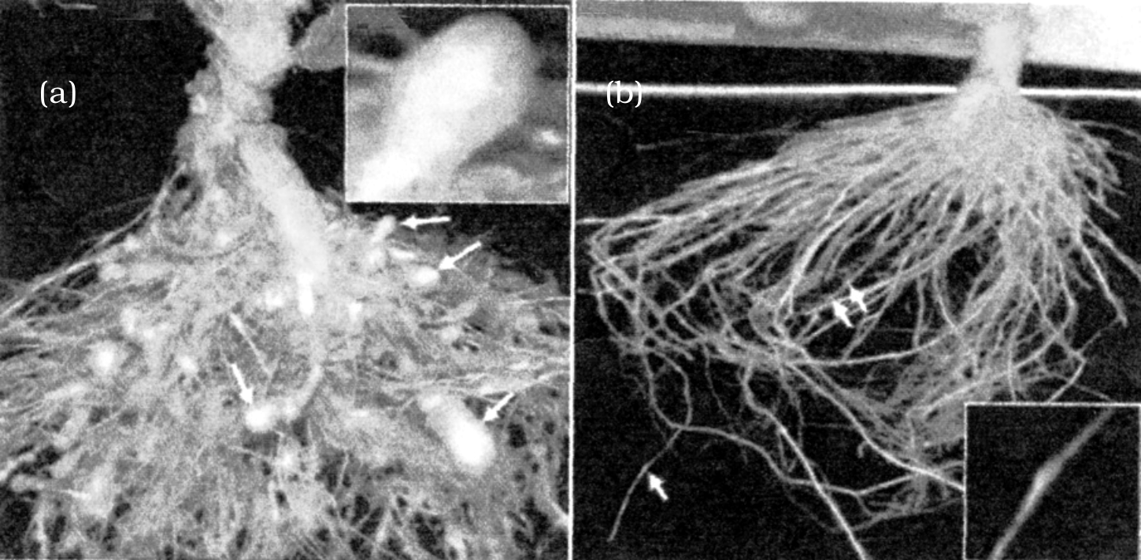
Fig. 10.2 -- Host plant-generated dsRNA triggers protection against nematode infestation: (a) Roots of a typical control plant, where the white arrows mark the swollen nematode-induced galls; (b) transgenic plant roots 5 days after deliberate infection of nematode but protected through the novel mechanism -- the arrows here point to thin, healthy roots and no galls have formed. Both root systems are the same colour in the source: the galls are identified by the arrows and their swelling, so nothing is lost in monochrome.
10.2 | BIOTECHNOLOGICAL APPLICATIONS IN MEDICINE

The recombinant DNA technological processes have made an immense impact in the area of healthcare by enabling mass production of safe and more effective therapeutic drugs.
• Because the recombinant therapeutics are identical to human proteins, they do not induce unwanted immunological responses and are free from the risk of infection -- unlike similar products isolated from non-human sources.
At present, about 30 recombinant therapeutics have been approved for human use the world over. In India, 12 of these are presently being marketed.
10.2.1 | Genetically Engineered Insulin

Management of adult-onset diabetes is possible by taking insulin at regular time intervals. What would a diabetic patient do if enough human insulin were not available? One would have to isolate and use insulin from other animals -- but would animal insulin be just as effective, and would it not elicit an immune response in the human body? The elegant answer is a bacterium that could make human insulin: one can then easily grow a large quantity of bacteria and make as much insulin as needed.
Insulin used for diabetes was earlier extracted from the pancreas of slaughtered cattle and pigs. Insulin from an animal source, though, caused some patients to develop allergy or other reactions to the foreign protein.
• Insulin consists of two short polypeptide chains -- chain A and chain B -- that are linked together by disulphide bridges (S-S) (Figure 10.3).
In mammals, including humans, insulin is synthesised as a pro-hormone (like a pro-enzyme, the pro-hormone also needs to be processed before it becomes a fully mature and functional hormone). This pro-hormone -- proinsulin -- contains an extra stretch called the C peptide, which is not present in the mature insulin and is removed during maturation into insulin.
The main challenge for producing insulin using rDNA techniques was getting insulin assembled into a mature form. The route used was:
1 | In 1983, Eli Lilly, an American company, prepared two DNA sequences corresponding to the A and B chains of human insulin.
2 | These sequences were introduced into plasmids of E. coli to produce the insulin chains. Chains A and B were produced separately.
3 | The two chains were extracted and combined by creating disulfide bonds to form human insulin -- whose structure is absolutely identical to that of the natural molecule.

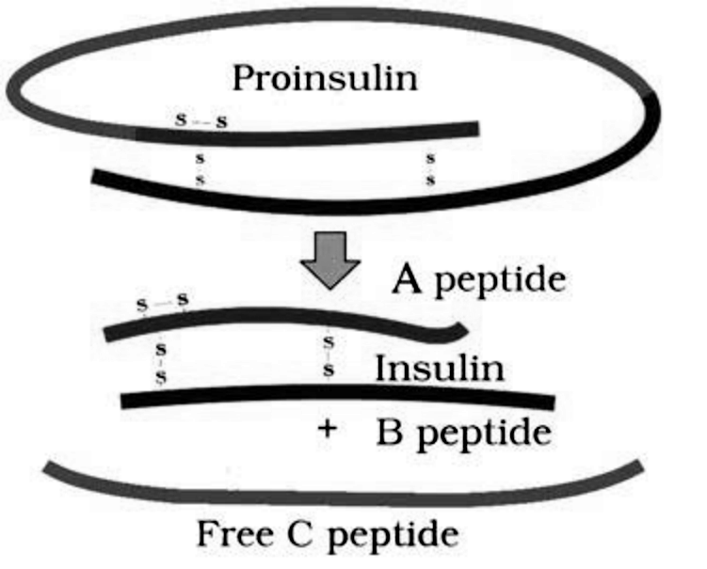
Fig. 10.3 -- Maturation of pro-insulin into insulin (simplified). Proinsulin (the looped precursor at the top, held by S-S disulphide bridges) is processed by removing the connecting arc, yielding mature Insulin -- the joined A peptide and B peptide -- plus the discarded Free C peptide. Reading the lower half: the upper wavy chain is the A peptide, the lower straight chain is the B peptide, and the free arc below is the C peptide removed on maturation. (The source distinguished the A and B chains by colour alone, which is why they are named here by position and shape.)
10.2.2 | Gene Therapy

• Gene therapy is a collection of methods that allows correction of a gene defect diagnosed in a child / embryo: genes are inserted into a person's cells and tissues to treat a disease. It does so by replacing a defective mutant allele with a functional one, or by gene targeting (which involves gene amplification). Correction involves delivery of a normal gene into the individual or embryo to take over the function of, and compensate for, the non-functional gene.
The first clinical gene therapy was given in 1990 to a 4-year-old girl with adenosine deaminase (ADA) deficiency. This enzyme is crucial for the immune system to function; the disorder is caused by the deletion of the gene for adenosine deaminase.
Earlier approaches to ADA deficiency | Limitation
Bone marrow transplantation (in some children). | Not completely curative.
Enzyme replacement therapy -- functional ADA given by injection. | Not completely curative.

The gene-therapy route used a retroviral vector -- one of the viruses that attack their hosts and introduce their genetic material into the host cell as part of their replication cycle, and are therefore used as vectors to transfer healthy genes:
1 | Lymphocytes from the blood of the patient are grown in a culture outside the body.
2 | A functional ADA cDNA (using a retroviral vector) is introduced into these lymphocytes.
3 | The lymphocytes are returned to the patient.

[NOTE] As these cultured cells are not immortal, the patient requires periodic infusion of such genetically engineered lymphocytes. However, if the gene isolated from marrow cells producing ADA were introduced into cells at early embryonic stages, it could be a permanent cure.

10.2.3 | Molecular Diagnosis

For effective treatment of a disease, early diagnosis and understanding its pathophysiology are very important. Using conventional methods of diagnosis (serum and urine analysis, etc.), early detection is not possible. Recombinant DNA technology, Polymerase Chain Reaction (PCR) and Enzyme Linked Immuno-sorbent Assay (ELISA) are some of the techniques that serve the purpose of early diagnosis.
Presence of a pathogen (bacteria, viruses, etc.) is normally suspected only after it has produced a disease symptom -- by which time the concentration of the pathogen is already very high in the body.
Technique | Principle | Use
PCR | Amplification of the nucleic acid of a bacterium or virus, so even a very low concentration (before symptoms appear) can be detected. | Routinely used to detect HIV in suspected AIDS patients; to detect mutations in genes in suspected cancer patients; and to identify many other genetic disorders.
Radioactive probe (hybridisation) | A single-stranded DNA or RNA tagged with a radioactive molecule (probe) is allowed to hybridise to its complementary DNA in a clone of cells, followed by detection using autoradiography. | The clone having the mutated gene will not appear on the photographic film, because the probe has no complementarity with the mutated gene.
ELISA | Based on the principle of antigen-antibody interaction. | Infection by a pathogen is detected by the presence of antigens (proteins, glycoproteins, etc.) or by detecting the antibodies synthesised against the pathogen.

10.3 | TRANSGENIC ANIMALS

• Transgenic animals are animals that have had their DNA manipulated to possess and express an extra (foreign) gene. Transgenic rats, rabbits, pigs, sheep, cows and fish have been produced, although over 95 per cent of all existing transgenic animals are mice.
Transgenic animals are produced for five common reasons:
Reason | What it is used for
(i) Normal physiology and development | To study how genes are regulated and how they affect normal body functions and development, e.g., the study of complex factors involved in growth such as insulin-like growth factor. Genes from other species that alter this factor are introduced, and the biological effects reveal the factor's role in the body.
(ii) Study of disease | To understand how genes contribute to disease, by serving as models for human diseases. Transgenic models exist for cancer, cystic fibrosis, rheumatoid arthritis and Alzheimer's.
(iii) Biological products | To produce useful, otherwise expensive, biological products by introducing the DNA (gene) that codes for it, e.g., human protein alpha-1-antitrypsin used to treat emphysema; similar attempts target phenylketonuria (PKU) and cystic fibrosis. In 1997, the first transgenic cow, Rosie, produced human-protein-enriched milk (2.4 grams per litre) containing human alpha-lactalbumin -- nutritionally more balanced for human babies than natural cow milk.
(iv) Vaccine safety | Transgenic mice are being developed to test the safety of vaccines before use on humans -- e.g., testing the polio vaccine; if reliable, they could replace the use of monkeys for testing safety of vaccine batches.
(v) Chemical safety testing | Also called toxicity / safety testing. Transgenic animals carrying genes that make them more sensitive to toxic substances are exposed to those substances and the effects studied, allowing results in less time.

10.4 | ETHICAL ISSUES

The manipulation of living organisms by the human race cannot go on any further without regulation. Some ethical standards are required to evaluate the morality of all human activities that might help or harm living organisms. Beyond morality, the biological significance also matters: genetic modification of organisms can have unpredictable results when such organisms are introduced into the ecosystem.
• Therefore, the Indian Government has set up organisations such as GEAC (Genetic Engineering Approval Committee), which makes decisions regarding the validity of GM research and the safety of introducing GM organisms for public services.
10.4 | Patents and biopiracy

The modification / usage of living organisms for public services (as food and medicine sources, for example) has also created problems with patents granted for the same. There is growing public anger that certain companies are being granted patents for products and technologies that make use of genetic materials, plants and other biological resources that have long been identified, developed and used by farmers and indigenous people of a specific region / country.
The case of rice illustrates this. Rice is an important food grain whose presence goes back thousands of years in Asia's agricultural history. There are an estimated 200,000 varieties of rice in India alone -- one of the richest diversities in the world. Basmati rice is distinct for its unique aroma and flavour, and 27 documented varieties of Basmati are grown in India, with references in ancient texts, folklore and poetry.
In 1997, an American company got patent rights on Basmati rice through the US Patent and Trademark Office, allowing it to sell a 'new' variety of Basmati in the US and abroad. This 'new' variety had actually been derived from Indian farmers' varieties: Indian Basmati was crossed with semi-dwarf varieties and claimed as an invention or novelty. The patent extends to functional equivalents, implying that other people selling Basmati rice could be restricted by the patent. Several attempts have also been made to patent uses, products and processes based on Indian traditional herbal medicines, e.g., turmeric and neem. If we are not vigilant and do not immediately counter these patent applications, other countries / individuals may encash on our rich legacy and we may not be able to do anything about it.
• Biopiracy is the term used to refer to the use of bio-resources by multinational companies and other organisations without proper authorisation from the countries and people concerned, and without compensatory payment.
Most industrialised nations are rich financially but poor in biodiversity and traditional knowledge. In contrast, the developing and underdeveloped world is rich in biodiversity and traditional knowledge related to bio-resources -- knowledge that can be exploited to develop modern applications and to save time, effort and expenditure during commercialisation.
There has been growing realisation of the injustice, inadequate compensation, and benefit sharing between developed and developing countries. Therefore, some nations are developing laws to prevent such unauthorised exploitation. The Indian Parliament has recently cleared the second amendment of the Indian Patents Bill, which takes such issues into consideration, including patent terms of emergency provisions, research, and development initiatives.
QR | QUICK RECAP

• Biotechnology has given humans several useful products by using microbes, plants, animals and their metabolic machinery.
• Tissue culture and somatic hybridisation offer vast potential for manipulating plants in vitro to produce new varieties (totipotency, micro-propagation, somaclones, virus-free plants, pomato).
• Recombinant DNA technology makes it possible to engineer microbes, plants and animals with novel capabilities. GMOs are made by non-natural transfer of one or more genes between organisms.
• GM plants increase crop yields, reduce post-harvest losses, make crops more stress-tolerant, improve nutrition (golden rice) and reduce pesticide use (Bt cotton, RNAi-based nematode resistance).
• Recombinant therapeutics are identical to human proteins, so they avoid unwanted immune responses and infection risk. Human insulin is made in bacteria yet is structurally identical to the natural molecule.
• Gene therapy inserts genes into an individual's cells / tissues to treat (especially hereditary) disease -- replacing a defective allele or using gene targeting; viruses are used as vectors. The first case (1990) treated ADA deficiency.
• PCR, radioactive probes and ELISA allow early molecular diagnosis. Transgenic animals (over 95% mice) model human disease and make biological products.
• The manipulation of microbes, plants and animals raises serious ethical questions; GEAC regulates GM research in India, and biopiracy / patent issues (Basmati, turmeric, neem) drive new protective laws.
EX | TERMS USED IN THE EXERCISES

A few end-of-chapter questions lean on a term or task the body states only indirectly. Each is closed below using only facts from this chapter.
Exercise term / task | Explanation from this chapter
Advantages vs disadvantages of GM crops (Q6) | Advantages (10.1): tolerance to cold, drought, salt and heat; reduced reliance on chemical pesticides; less post-harvest loss; more efficient mineral use, sparing soil fertility; better nutrition (golden rice); plus tailor-made starches, fuels and pharmaceuticals. Disadvantages (10.4): genetic modification can have unpredictable results when such organisms are introduced into the ecosystem, which is why GEAC clearance is required; and the patenting of GM and bio-resource material raises biopiracy problems, since a patent extending to functional equivalents can restrict others (the Basmati case).
Transgenic bacteria (Q5) | The chapter defines transgenic animals; by the same idea, a transgenic bacterium is a bacterium carrying an introduced foreign gene. Example: the E. coli into which Eli Lilly introduced the human insulin A- and B-chain DNA sequences (1983) to make human insulin.
Cry proteins (Q7) | The toxic insecticidal proteins that form the crystals of Bacillus thuringiensis. They are encoded by the cry gene family (e.g., cryIAc, cryIIAb against cotton bollworms; cryIAb against corn borer). Man has cloned these genes into crops (Bt cotton) to create insect resistance.
Cloning and expressing a human gene in E. coli (Q9) | The route this chapter supplies is the insulin one: prepare DNA for the A and B chains, insert into E. coli plasmids, produce each chain, then combine them by disulfide bonds. (The full general rDNA step sequence belongs to Chapter 9.)
Removing oil (hydrocarbon) from seeds (Q10) | The silencing tool the chapter provides is RNAi: introducing DNA that makes sense and anti-sense RNA forms a dsRNA that silences the target mRNA -- the same strategy used against the nematode -- pointing to how an oil-synthesis gene could be switched off.
Proteases and nucleases in blood; oral protein drugs (Q12, Q13) | This is why insulin cannot simply be swallowed: as a protein, it would be digested in the gut, so it must be injected. Any orally active protein pharmaceutical faces this same digestion problem.

